Ionia County
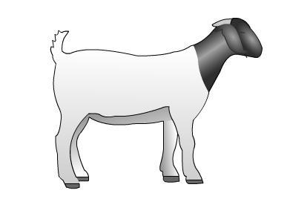

4-H Record Book

Market Goat
Cloverbud (5-7)

Place Beginning Project Picture Here |  | Place Ending Project Picture Here

Name: _____________________________________________________________

4-H Age (as of Jan. 1)_____________

Club: ______________________________________________________________

Years in 4-H: _____________________ Years in Project: __________________

Are you borrowing an animal or do you have your own? __________________

Member’s Signature: ________________________________________________

Parent’s Signature: __________________________________________________

Leader’s Signature: _________________________________________________

Ionia County Market Goat Record Book page 1 of 8 5 - 8 Year Old Rev. 5.1.18

 | The 4-H Pledge
Draw a line to the correct word or write in the word.
I pledge…
My |  | to clearer thinking,
My |  | to greater loyalty,
My |  | to larger service,
My |  | to better living,

for my club, my community, my country and my world.


Hands Health Head ^{Heart}

Ionia County Market Goat Record Book page 2 of 8 5 - 8 Year Old Rev. 5.1.18

Meetings / Participation
Keep track of meetings/events that you have participated in. Put a check in the appropriate month.

Description | Sep Oct Nov Dec Jan Feb Mar Apr May Jun Jul Aug

Club Meetings (list)

General Meetings (list)

County Events: (list)

State Events: (list)

Community Service: (list)

Committees: (list)

Other: (list)

Examples: Kettunen Center, Shows, Clinics, Workshops, etc.

Ionia County Market Goat Record Book page 3 of 8 5 - 8 Year Old Rev. 5.1.18

A Good Showperson….

Circle True or False

True / False

True / False

True / False

True / False

True / False

True / False

True / False

True / False

True / False

True / False

True / False

True / False

True / False

True / False

True / False

Wears dirty pants and shirts

Has animal clean and presentable

Talks to friends while in the show ring

Is polite to other exhibitors

Keeps the animal under control

Keeps eye contact with the judge

Gives up if the animal misbehaves

Helps other exhibitors with their animals

Wears sandals in the show arena

Sets up the animal in the proper position

Gets upset when they lose

Is on-time for their class

Says bad things about other exhibitors

Believes winning is everything

Remembers to have a good time

Ionia County Market Goat Record Book page 4 of 8 5 - 8 Year Old Rev. 5.1.18

Things a Judge Might Ask:

Below are some questions that a judge might ask you about your animal while you are showing.

- What is your animal’s name?

- What is the breed of your animal?

- What is the birth date of your animal?

- How old is your animal?

- How much does your animal weigh?

- Is your animal a doe or a wether?

Ionia County Market Goat Record Book page 5 of 8 5 - 8 Year Old Rev. 5.1.18

Goat Body Parts
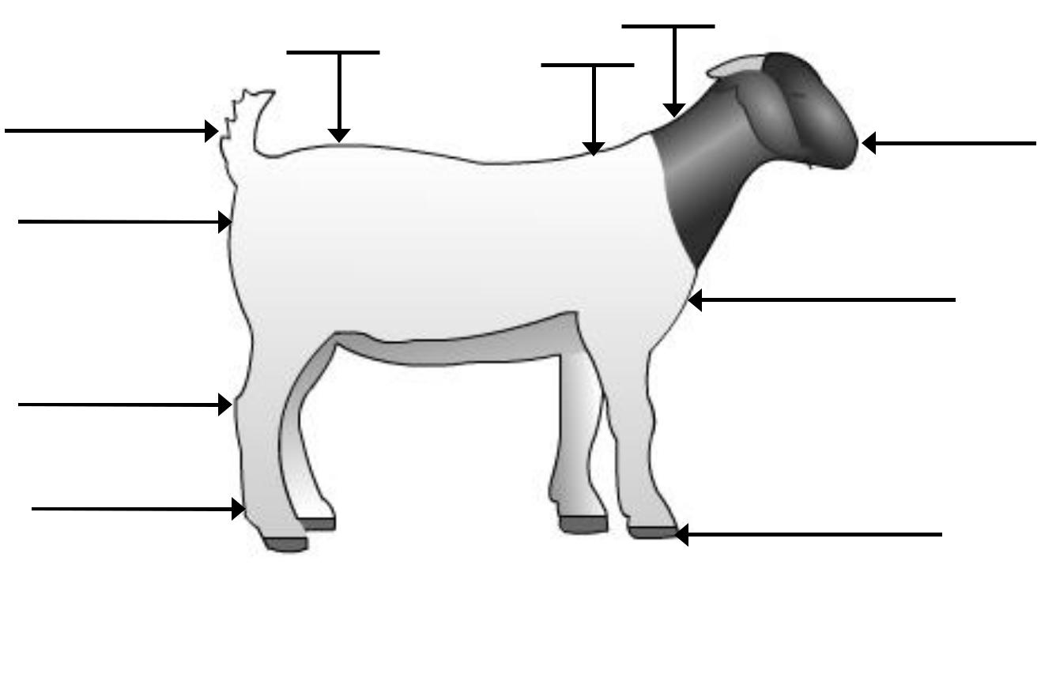

1. | Brisket | 3. | Hock | 5. | Muzzle | 7. | Pin Bone | 9. Tail
2. | Dew | 4. | Hoof | 6. | Neck | 8. | Rump | 10. Withers
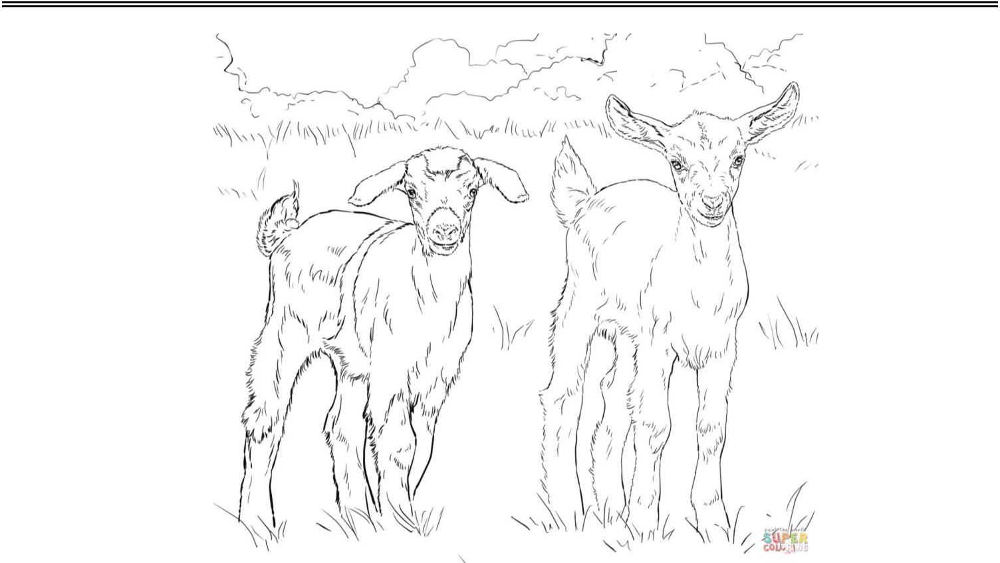

Color in the Goat

Ionia County Market Goat Record Book page 6 of 8 5 - 8 Year Old Rev. 5.1.18

Financial Summary
(5 & 6 year olds do not need to complete this page)

 |  | - |  |  | = |  | divided |  |  | =
 | Ending | - |  | Beginning | = | Pounds | divided |  | Days on | = | Average
 | Ending | - |  | Beginning | = | Pounds | / |  | Days on | =
 | Weight | minus |  | Weight | equals | Gained | by |  | Feed | equals | Daily Gain
 |  |  |  | Record of Feed Expense
 | Month |  |  |  | Type of Feed |  |  |  | Total Dollar Amount

TOTAL FEED EXPENSE


Record of Other Expense
 | Month | Type of Feed | Total Dollar Amount
TOTAL OTHER EXPENSE


INCOME
Ending Weight: |  | X | Market Price: | = | Estimated Income
 |  | X |  | = | from Animal:
Other Income: (List items:)
TOTAL ESTIMATED INCOME

EXPENSES

Purchase price of animal (if homegrown = market value @ weigh in)

Cost of Feed

Cost of Other Expense

TOTAL EXPENSES

PROFIT / (LOSS): Income minus Expense (negative number equals a loss)

Ionia County Market Goat Record Book page 7 of 8 5 - 8 Year Old Rev. 5.1.18


My Project Story


Ionia County Market Goat Record Book page 8 of 8 5 - 8 Year Old Rev. 5.1.18

