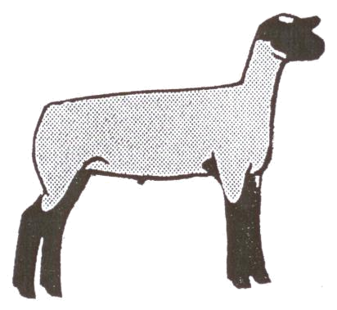
Ionia County 4-H Record Book Market Sheep Junior (8-11)
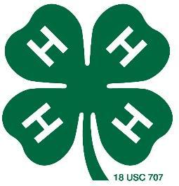

Place Beginning Project Picture Here |  | Place Ending Project Picture Here

Name: _____________________________________________________________

4-H Age (as of Jan. 1)_____________

Club: ______________________________________________________________

Years in 4-H: _____________________ Years in Project: __________________

Member’s Signature: ________________________________________________

Parent’s Signature: __________________________________________________

Leader’s Signature: _________________________________________________

Ionia County Sheep Record Book page 1 of 12 9-11 Year Olds Rev. 4.18.18

Why Keep Records?

By keeping records, you will be able to see how much progress you make this year and over the course of your 4-H career as you set goals and work to accomplish them. Good records will:

- Help you learn about animals, their rate of growth, the feed they require, the cost of the feed they require and their habits.

- Increase understanding of your project’s financial outcome.

- Assist you in gathering information to market your animal.
- Improve your management practices.
- Keep track of your project activities and learning experiences.
- Allow you to better plan for future livestock projects.

If you have questions or need help on this record book, please contact your leader, parent/guardian, or County MSU Extension Office.

4-H Information
The 4-H Pledge
Fill in the Blanks

I pledge…
My _________ to _______________,

My _________ to _______________,

My _________ to _______________,

My _________ to _______________,

for my club, my community,

my country and my world.

The 4-H Motto
Fill in the Blanks

“To Make the ______, __________”

What 4-H Means to Me
Describe what 4-H means to you.

___________________________________________________________________

___________________________________________________________________

___________________________________________________________________

___________________________________________________________________

Ionia County Sheep Record Book page 2 of 12 9-11 Year Olds Rev. 4.18.18
Meetings / Participation
Keep track of meetings/events that you have participated in. Put a check in the appropriate month.

Description | Sep Oct Nov Dec Jan Feb Mar Apr May Jun Jul Aug

Club Meetings (list)

General Meetings (list)

County Events: (list)

State Events: (list)

Community Service: (list)

Committees: (list)

Other: (list)

Examples: Kettunen Center, Shows, Clinics, Workshops, etc.

Ionia County Sheep Record Book page 3 of 12 9-11 Year Olds Rev. 4.18.18
My Market Animal Project

- Name and description of animal: ____________________________________________________________

_______________________________________________________________________________________

- Where did you get your project animals? Reasons for selecting that breeder, farm, or business?___________

_______________________________________________________________________________________

_______________________________________________________________________________________

- What type of housing did you provide your animals? ____________________________________________

_______________________________________________________________________________________

- How did you provide fresh water to your animals? ______________________________________________

_______________________________________________________________________________________

- List two things you have learned in your project this year.

  - ____________________________________________________________________________________

  - ____________________________________________________________________________________

- Who has influenced you the most this year in this project and why? ________________________________

_______________________________________________________________________________________

_______________________________________________________________________________________

- List two qualities of a good showperson:

  - ____________________________________________________________________________________

  - ____________________________________________________________________________________

- List two qualities of a bad showperson:

  - ____________________________________________________________________________________

  - ____________________________________________________________________________________

- List the names of three potential buyers that you contacted about the Livestock Sale for this project:

1.__________________________ 2. __________________________ 3. __________________________

Ionia County Sheep Record Book page 4 of 12 9-11 Year Olds Rev. 4.18.18
Sheep Body Parts
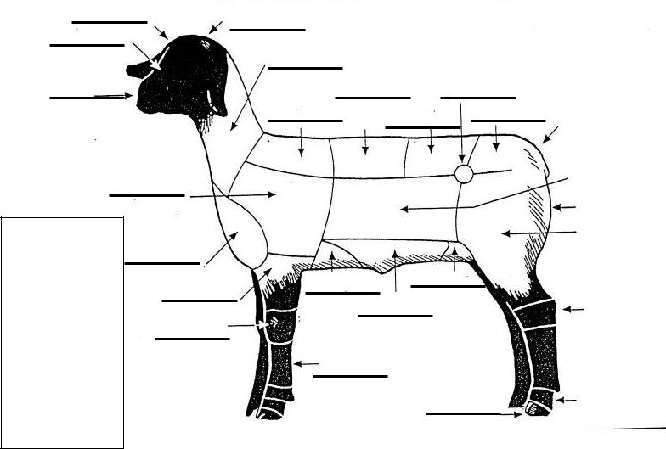

Body Parts:
Write in the

number of the
body part from
the table to the
right that
matches the
correct part on
the animal.

Pick 10 parts

to label.

Diseases
List 2 common diseases of sheep

- ____________________________

- ____________________________

Breeds
List 2 breeds of sheep

- ____________________________

- ____________________________

 |  |  |  |  | 1. |  | Back/Rack
 |  |  |  |  | 2. |  | Belly
 |  |  |  |  | 3. |  | Brisket
 |  |  |  |  | 4. |  | Cannon
 |  |  |  |  | 5. |  | Dock
 |  |  |  |  | 6. |  | Face
 |  |  |  |  | 7. |  | Fore Flank
 |  |  |  |  | 8. |  | Forearm
 |  |  |  |  | 9. |  | Forehead
 |  |  |  |  | 10. |  | Hips
 |  |  |  |  | 11. |  | Hock
 |  |  |  |  | 12. |  | Hoof
 |  |  |  |  | 13. |  | Knee
 |  |  |  |  | 14. |  | Leg
 |  |  |  |  | 15. |  | Loin
 |  |  |  |  | 16. |  | Middle
 |  |  |  |  | 17. |  | Muzzle
 |  |  |  |  | 18. |  | Neck
 |  |  |  |  |  | 19. | Pastern
 |  |  |  |  | 20. |  | Poll
 |  |  |  |  | 21. |  | Rear Flank
 |  |  |  |  | 22. |  | Rump
 |  |  |  |  | 23. |  | Shoulder
 |  |  |  |  | 24. |  | Top of Shoulder
 |  |  |  |  |  | 25. | Twist

By – Products
List 2 by-products of sheep

- ____________________________

- ____________________________

Retail Meat Cuts
List 2 retail meat cuts of sheep

- ___________________________

- ___________________________

Ionia County Sheep Record Book page 5 of 12 9-11 Year Olds Rev. 4.18.18

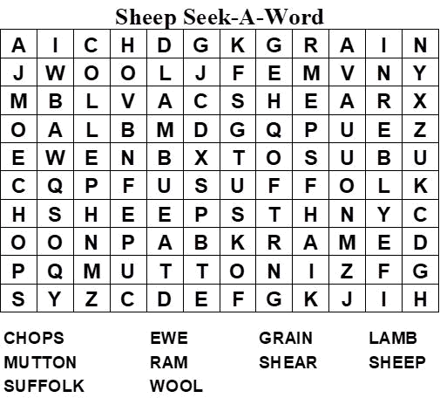

Ionia County Sheep Record Book page 6 of 12 9-11 Year Olds Rev. 4.18.18
Sheep Weigh Chart

Weight, Pounds

200


175

150

125

100

75

50

25

0 | 10 | 20 | 30 | 40 | 50 | 60 | 70 | 80 | 90

Days of Project

Knowing how much your animal weighs and how much it is gaining each day is a critical part of raising a healthy animal. Weights can be measured by using scales, weight tapes, or estimated. Keep track of the weights in the table below and draw the results
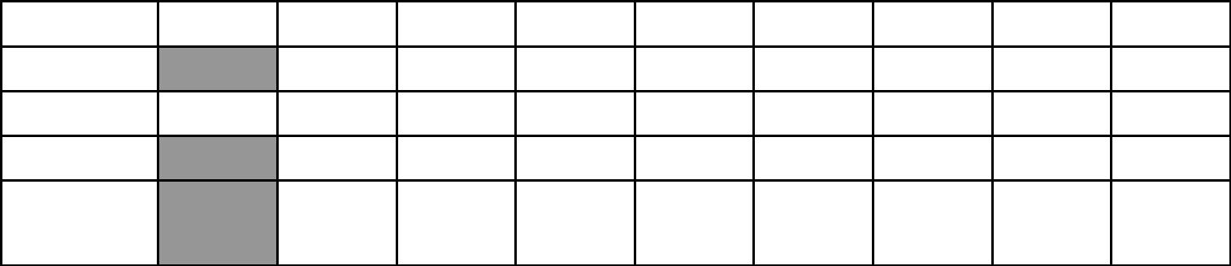

Date Weighed

# of Days

Weight

Lbs. Gained

A.D.G.

(Lbs. Gained /

# of Days)

Ionia County Sheep Record Book page 7 of 12 9-11 Year Olds Rev. 4.18.18

Sheep Feed / Expense Record

Write the information from the feed tag or the “recipe” mixture that you use: ___________________________

__________________________________________________________________________________________

__________________________________________________________________________________________

Pounds Fed |  | Mar |  | Apr |  | May |  | Jun |  | July | TOTAL
Hay / Roughage
Grains
(include all types of grain: corns, oats, etc.)
Minerals
Other:
TOTAL Pounds Fed:
TOTAL Cost of Feed: | $ |  | $ |  | $ |  | $ |  | $ |  | $
Expense Items |  | Mar |  | Apr |  | May |  | Jun |  | July | TOTAL
Veterinary Charges
Vaccinations
Wormer
Bedding
Housing
Other:
TOTAL Expense Items: | $ |  | $ |  | $ |  | $ |  | $ |  | $

Ionia County Sheep Record Book page 8 of 12 9-11 Year Olds Rev. 4.18.18
Project Performance Summary

 |  | - |  |  |  | = |  |  |  | divided |  |  |  | =
 | Ending | - | Beginning |  |  | = | Pounds |  |  |  |  | Days on |  | = |  | Average
 |  |  |  |  |  |  |  |  | / |  |  |  |  | = |  | Average
 | Weight | minus |  | Weight |  | equals | Gained |  |  | by |  | Feed |  | equals |  | Daily Gain
 |  |  |  |  |  | divided
 |  |  |  | Total |  | divided | Total Lbs. |  |  | equals⁼ Feed Cost per
 |  |  |  |  |  | /
 |  |  | Feed Cost |  |  | by | of Gain |  |  |  |  | Pound of Gain
 |  |  |  |  |  | divided
 |  |  | Total Lbs. |  |  | divided | Total Lbs. |  |  | equals⁼ Lbs. Of Feed Fed
 |  |  |  |  |  | /
 |  |  | Of Feed Fed |  |  | by | of Gain |  |  |  |  | per Lb. Of Gain
 |  |  |  | Financial Summary
INCOME
 | Ending Weight: |  |  | X | Market Price: |  |  |  | = |  |  | Estimated Income
 |  |  |  | X |  |  |  |  |  |  |  | from Animal:
Other Income: (List items:)

TOTAL ESTIMATED INCOME

EXPENSES

Purchase price of animal (if homegrown = market value @ weigh in)

Cost of Feed (page 8)

Cost of other Expense items (page 8)

TOTAL EXPENSES

PROFIT / (LOSS): Income minus Expense (negative number equals a loss)

Ionia County Sheep Record Book page 9 of 12 9-11 Year Olds Rev. 4.18.18
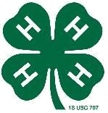
My Project Story

_____________________________________________________________________________

_____________________________________________________________________________

_____________________________________________________________________________

_____________________________________________________________________________

_____________________________________________________________________________

_____________________________________________________________________________

_____________________________________________________________________________

_____________________________________________________________________________

_____________________________________________________________________________

_____________________________________________________________________________

_____________________________________________________________________________

_____________________________________________________________________________

_____________________________________________________________________________

_____________________________________________________________________________

_____________________________________________________________________________

_____________________________________________________________________________

_____________________________________________________________________________

_____________________________________________________________________________

_____________________________________________________________________________

Ionia County Sheep Record Book page 10 of 12 9-11 Year Olds Rev. 4.18.18
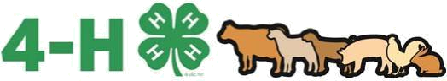

Michigan 4-H Animal Sheep

Project Record Book Supplement Page

Leadership and Service

Please answer the following questions according to your assigned age category: Beginners-question 1; Intermediate-questions 1-2; Advance-questions 1-3. Additional pages may be attached as needed.

1. In your animal project, what chores are assigned for you to do?

- Describe a time when you have helped someone else learn about animals or agriculture; this can be an individual (friend or family member) or public education such as your club offering a petting zoo at a local event.

- What is the leadership or service purpose of animal organizations such as Michigan Sheep Breeders, American Rabbit Breeders Association, etc? What organizations represent your animal species?

Ionia County Sheep Record Book page 11 of 12 9-11 Year Olds Rev. 4.18.18
Junior Sheep Record Book Score Sheet

4-H Member:_________________________________________________________________

4-H Club:____________________________________________________________________

Page | Description | Possible | Your
Page | Description | Points | Points
1 | COVER PAGE | 5
1 | Completely filled out with all signatures and both pictures. | 5
2 | 4-H INFORMATION | 5
3 | MEETINGS/PARTICIPATION | 5
4 | MARKET ANIMAL PROJECT QUESTIONS | 15
4 | Each question is completely and clearly answered. | 15
5 | PARTS OF ANIMAL | 10
5 | Placed correctly and information filled out. | 10
6 | WORD SEARCH | 5
7 | SHEEP WEIGH CHART | 10
8 | FEED AND EXPENSE ITEMS | 10
9 | PROJECT PERFORMANCE SUMMARY | 15
10 | MY PROJECT SUMMARY | 10
10 | Descriptive and at a minimum fills entire page. | 10
11 | SUPPLEMENT PAGE | 10
 | TOTAL POINTS | 100
 | A: 90-100, B: 80-89, C: 70-79 | 100

MSU is an affirmative-action, equal-opportunity employer. Michigan State University Extension programs and materials are open to all without regard to race, color, national origin, gender, gender identity, religion, age, height, weight, disability, political beliefs, sexual orientation, marital status, family status or veteran status.

Ionia County Sheep Record Book page 12 of 12 9-11 Year Olds Rev. 4.18.18

