Changing a Member’s Club, Retaining Projects
Before You Start
If a Club is simply removed from a member’s approved enrollment, the projects that they have enrolled in will be removed from their profile. To prevent losing the member’s projects, the manager should instead Swap the Club for a new Club using the steps below.

Steps  - Log in to your County Manager account.  - Click on the Enrollments tab and the Approved enrollments subtab and search for the member.  - Click on the name of the Club or Unit. | Screenshots  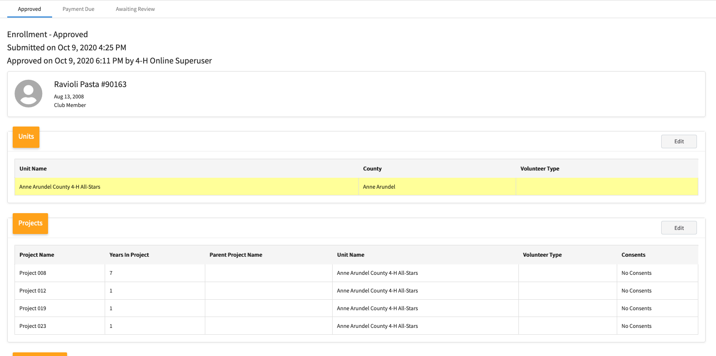  (Screen appearance may vary per state)
- Click the gray “Swap Unit” (or Club) button. | 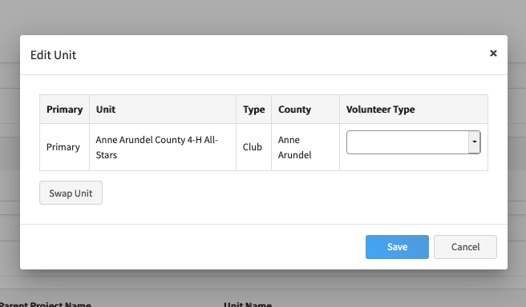
- Select the new Club.  - Click Save. | 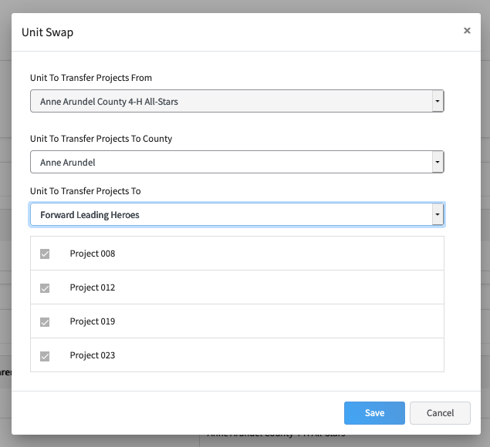
- The member’s projects will be assigned to the new Club. | 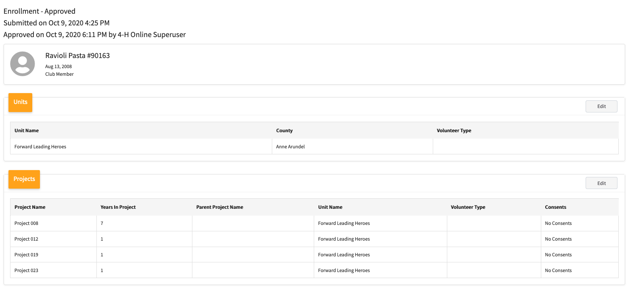

Updating the Member’s Primary Club on the Member Search after Swapping Clubs
There are instances where the Member’s Primary Club may not update in the Member Search after swapping clubs. If this happens when you swap clubs, use the steps below to force the Member Search to update.
- Go to Enrollments > Approved tab.
- Search and select the member’s record.
- Click Edit next to the Clubs/Units section.
- Verify the correct club is designated as the Primary Club.
- Click Save without making any changes.
- Do a new Member search for the individual to confirm the Primary Club has updated.

