Creating and Modifying Awards
Before You Start
Institution Managers can create and modify program level Awards. County Managers can create and modify county level Awards.

When modifying/updating Awards, it’s important to know that Awards that are inactivated will not impact the member’s award history, but will not be available to be added to additional member records.

Creating Awards  - Click on Awards in the navigation pane.  - Click the “Add Award” button. | Screenshots  (Screen appearance may vary per state)  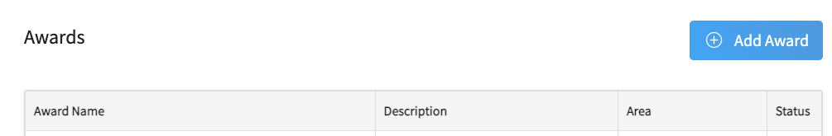
- Enter the Award name.  - Enter a description of the award.  - Select the status of the award (Active or Inactive).  - Click Save.  Note: The Area field will list the level of the hierarchy corresponding to the award. | 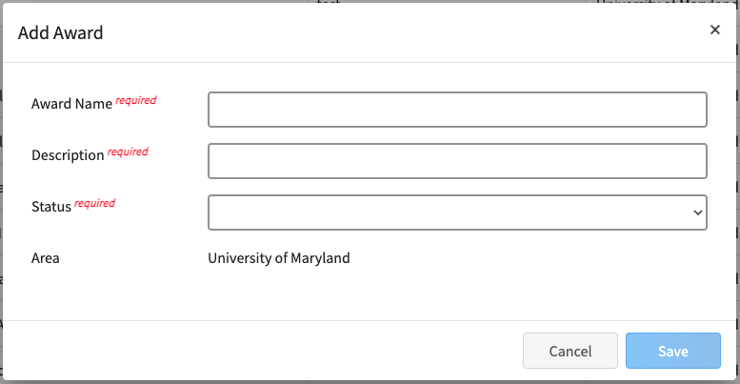
Modifying Awards  - Click on Awards in the navigation pane.  - Click the title of the Award to be modified. | 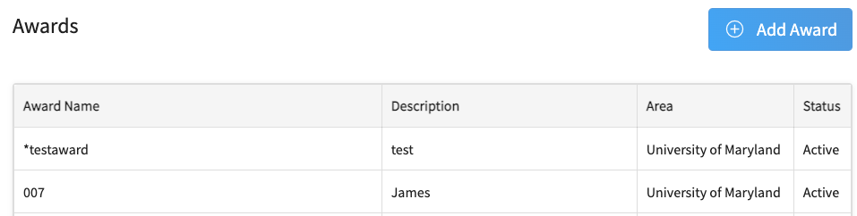
- Click the Edit button for the award. | 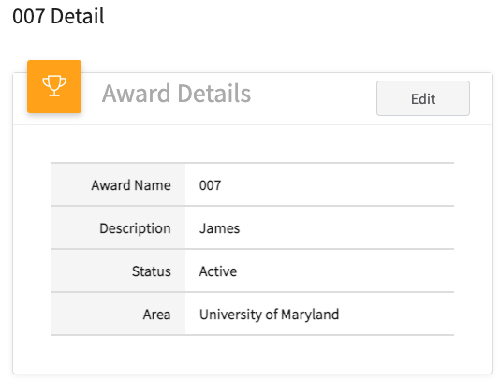
- Click the drop-down menu for the Status field.  - Select Inactive.  - Click Save.  NOTE: Managers may also make corrections to the Award Name or Description. In those cases, the award status does not need to be changed to Inactive before saving the corrections. | 