Creating a Folder for Custom Reports
Before You Start
A custom report folder must exist before a custom report can be created.
Steps  - Click on the Custom Reports tab in the Navigation Pane.  - Click on the Add Folder button. | Screenshots  (Screen appearance may vary per state)  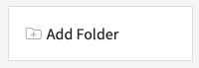
- Enter the name of the folder, then click the Add button. | 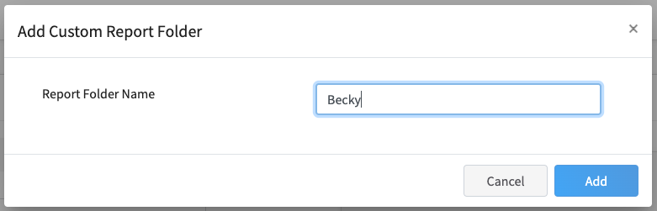
- To re-name a folder, click on the folder, then the Edit Folder button.

