Flagging Member Records
Before You Start
Member records may be flagged on the Member Search screen. The flagged records can then be added in bulk to an activity, award, group. You can also send a broadcast email to a flagged set of members, download the screen info, and print health forms.

IMPORTANT: Before beginning a new search to flag records, always use the Flag Options button to Clear All Flagged Results, so that the flags from a previous search are not included in the current search.
Steps  - Click on Members in the Navigation Pane.  - Use the Search filters at the top of the page to locate the record(s) you need to flag. | Screenshots  (Screen appearance may vary per state)
- Flag records one record at a time by clicking the Flag icon next to the Member record. To remove a flag from an individual record, click on the Flag icon again, and it will change from green back to white.  - When you have selected/flagged all appropriate records, use the Flagged checkbox in the search options to leave only those flagged records on screen. | 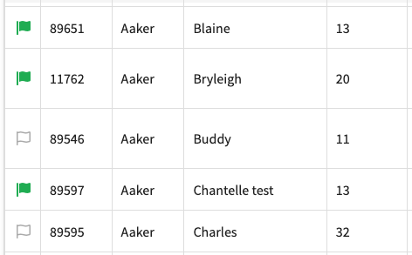
- To flag all records listed on screen at one time, use the Flag Options button. This is also where Activities, Awards, and Groups can be added to all flagged records at one time.  - To remove all flags from the records, use the Clear All Flagged Results option. | 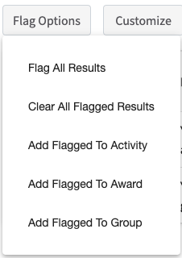
- When you have (only) the Flagged records displayed, you can use the Broadcast, Download Excel, and Health Forms buttons with those records. | 