Poultry Community Service
Project Record Book

Name: ____________________________________ Date of Birth: _______________
Year (example: 2015): ____________ Age (as of Jan 1st): _________________
Is this your first year in project? Yes ____ No ____
If No, how many years have you been doing project: ____________________________________
Club Name: ___________________________________________________________________
Project Leader: _________________________________________________________________
I hereby certify that, as the exhibitor of this project, I have personally been responsible for the care of this animal, record keeping, and have completed this record book. I am aware that this record book may be on display during the auction and/or fair, and thus all content will be appropriate.
Youth Signature: ______________________________________ Date: ____________
I, the parent/guardian, certify that my son/daughter has completed this project and completed this record book and will comply with all rules and regulations. I give permission for this record book to be displayed to the public and will ensure that all content is appropriate.
Parent/Guardian Signature: _____________________________ Date: _____________
Check with your local 4-H staff to determine when your record book needs to be submitted and any additional guidelines or rules for completion.

**RECORDS START WITH POSSESSION OF YOUR ANIMAL(S) AND END WITH FAIR WEEK ESTIMATES! **

MSU is an affirmative-action, equal-opportunity employer. Michigan State University Extension programs and materials are open to all without regard to race, color, national origin, gender, gender identity, religion, age, height, weight, disability, political beliefs, sexual orientation, marital status, family status or veteran status.

Why Keep Records?
By keeping records, you will be able to see how much progress you make this year and over the course of your 4-H career as you set goals and work to accomplish them.
Good records will:
- Help you learn about animals, their rate of growth, the feed they require, the cost of the feed they require and their habits.
- Increase understanding of your project’s financial outcome.
- Assist you in gathering information to market your animal.
- Improve your management practices.
- Keep track of your project activities and learning experiences.
- Allow you to better plan for future livestock projects.
If you have questions or need help on this record book, please contact your leader, parent/guardian, or County MSU Extension Office.
PLEASE PRINT OR WRITE CLEARLY.

Project Information (Submit one completed record book for each species)

Species: _____________________________________________________________________
Breed(s): _____________________________________________________________________
Identification of animal(s) (if applicable)(example: leg band numbers): _____________________________________________________________________________
Estimated hatch date of animal(s): _________________________________________________
Date of ownership or purchase date: ________________________________________ Estimated beginning value of animal(s): ______________________________________
Please tell us about your project animal (check all that apply):
Purchased my project animal(s)
Project animal(s) are bred & owned (from an animal on my family farm)
Other (please explain): _____________________________________________
Comments by Leader/Parent (optional): ______________________________________
______________________________________________________________________
______________________________________________________________________
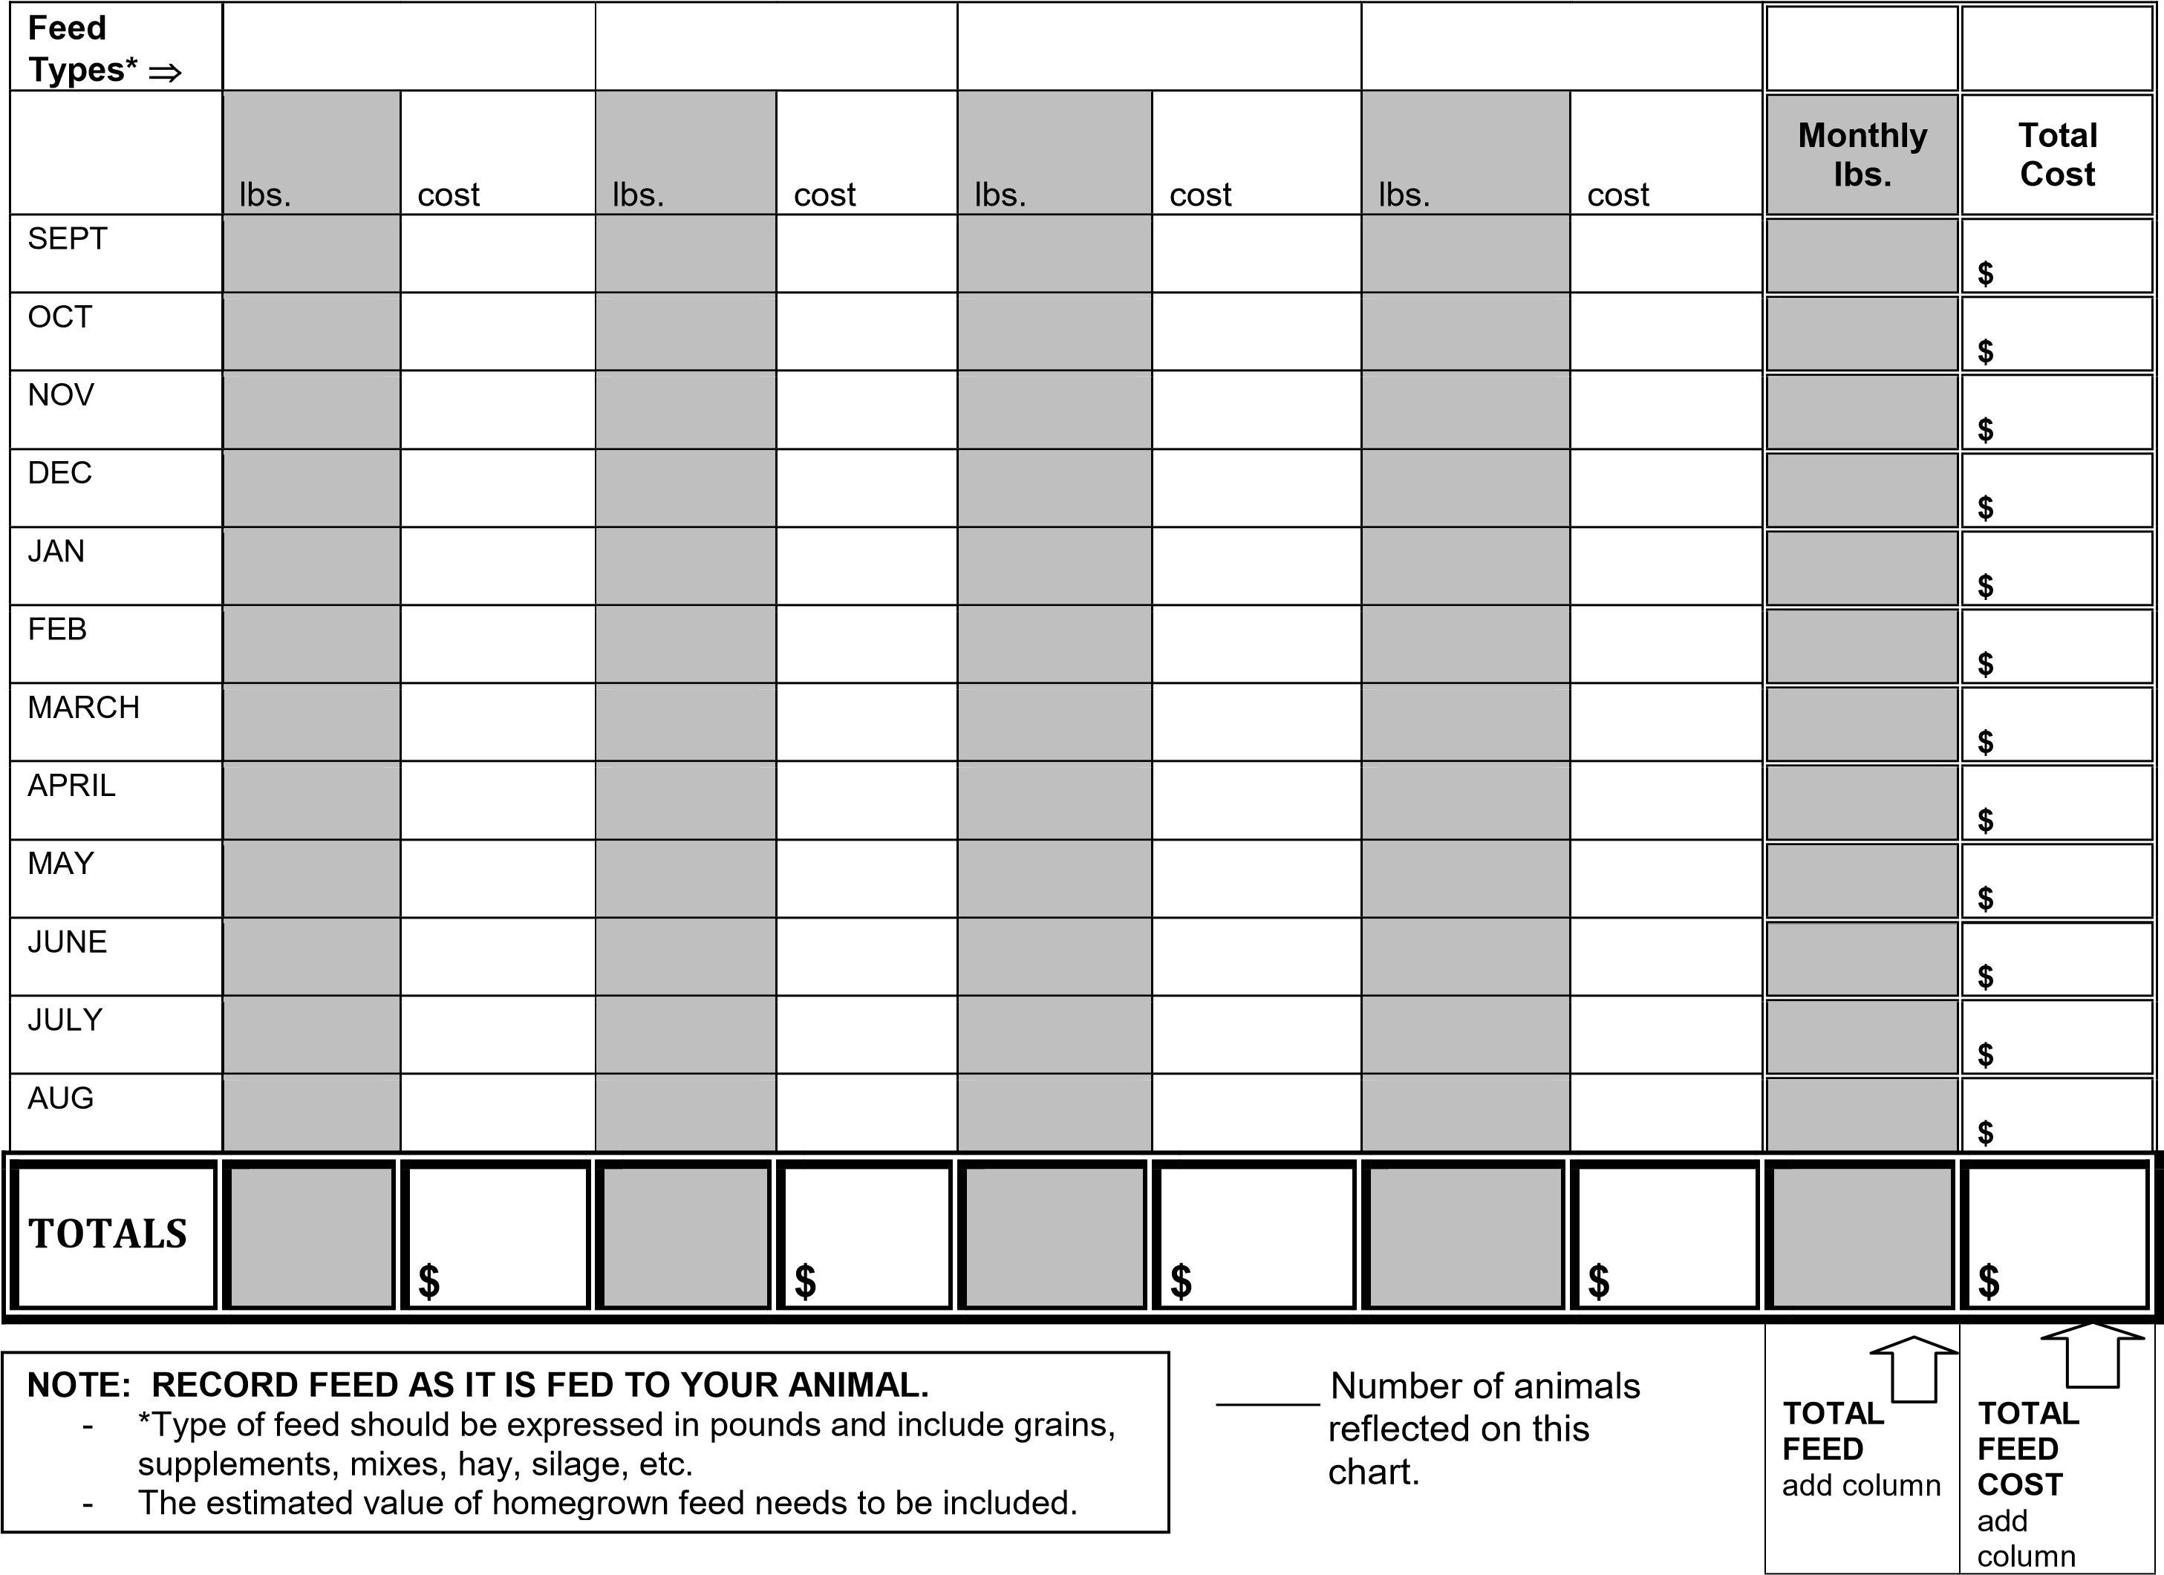
Monthly Feed Record Worksheet (Add additional pages if needed)
Expense Categories | Bedding | Medication  (If needed) | Miscellaneous  (Specify) | Equipment  (If needed) | Monthly Total
FEB |  |  |  |  | $
MARCH |  |  |  |  | $
APRIL |  |  |  |  | $
MAY |  |  |  |  | $
JUNE |  |  |  |  | $
JULY |  |  |  |  | $
TOTALS |  |  |  |  | TOTAL  $
Expenses Worksheet
*other than feed

_____ Number of animals reflected on this chart.

$_______ Total expense per animal

$_________TOTAL EXPENSES

*This page will be used for the following years community service project.
Please, fill it out to the best of your knowledge so that we can have a better estimate on cost.

Weight Record (Add additional pages if needed)
It is recommended to weigh your animal(s) at least once each month.
Use the chart below for each animal.
Animal ID: ______________ |  | Animal ID: ______________ |  | Animal ID: ______________
Date | Weight | Date | Weight | Date | Weight
(Beginning) |  | (Beginning) |  | (Beginning)
(Final) |  | (Final) |  | (Final)

Project Reflection:
Please respond to the following questions (additional pages can be added).

- What did you learn in the project this year? _____________________________________

__________________________________________________________________________

__________________________________________________________________________

__________________________________________________________________________

- How did you care for your project animal(s)? ____________________________________
__________________________________________________________________________
__________________________________________________________________________

__________________________________________________________________________
- What management strategies did you implement to improve animal health and well-being?
Did you have any loses? ___________________________________________________
__________________________________________________________________________
__________________________________________________________________________ __________________________________________________________________________
4. Would you participate in this project again? Why? ______________________________________________________________________________________________________________________________________________________
5. Why did you decide to do the community service project? ______________________________________________________________________________________________________________________________________________________
6. What have you done to help other members be successful in this project?
___________________________________________________________________________
___________________________________________________________________________
___________________________________________________________________________

