

Sheep

**Mentor—First Year**

Cloverbud

Mentor

**YEAR**

Welcome!!

Welcome to the Cloverbud Mentor Program. This is an exciting program where you as one of the younger members will get to experience the joys of working with an animal. This program is designed to give you the basic information about Sheep. Throughout this booklet you will get the opportunity to color, do crossword puzzles, word searches and much more all while learning about sheep.

You and your mentor will meet regularly and during these meetings you are to go through this booklet and discuss and learn the different topics that were chosen by the Jr. Livestock Committee. The topics covered in this booklet were chosen to be the most important things a new member should know.

At the end of each page you and your mentor are to sign both of your signatures. This shows that you both worked on this booklet and understand the information provided.

The topics covered in this booklet include: breeds of sheep, terminology, parts of the animal, safety and handling, what it takes to raise your animal, different feeds, animal fitting and showing and by-products. These chosen topics cover every aspect of the beef animal.

We as the 4-H Staff hope you have fun working with your animal and your mentor and learn a lot while doing it.

Sincerely,

4-H Staff



Prepared by Jessica Hammer, Washtenaw County 4-H alumni

Breeds of Sheep

**Dorset Hampshire**

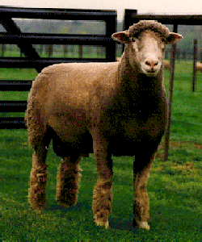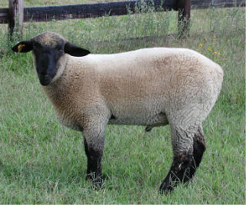

Dorsets are an all-white sheep of medium The Hampshire sheep acquired its

size having good body length and muscle name from the agricultural county of

conformation to produce a desirable carcass. Hampshire in Southern England

The fleece is very white, strong, close and where they were developed. The Hampshire

free from dark fiber. is a large, open-faced and active sheep with

a mild disposition. The ears should be moderate in length, thick, covered with a coarse dark brown or black hair and free from wool. The face should be of good length, dark in color and practically free of wool from the eyes down.

**Suffolk Columbia**

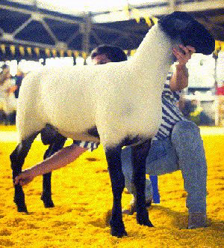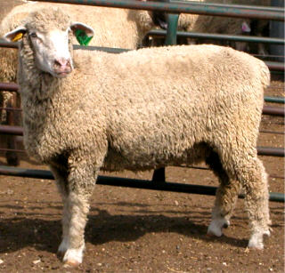

The Suffolk did not make its appearance Columbia sheep were developed by the

in the western states until 1919. Three United States Department of Agriculture

ewes end two rams had been donated by as a true breeding type to replace cross

the English Suffolk Sheep Society to the breeding on the range. Columbians are the

University of Idaho. The head should be largest white-faced sheep in the world.

black, the legs should be straight and black.

The fleece should be dense, free of dark Signature: ______________________

fiber. _______________________

A Family is a Family!

Just like you have a mom and a dad, so do animals, they are just called different names. Every species of animals has their own terminology for moms and dads, boys and girls, and even the family as a whole. Can you figure out which name belongs where?

Match the term with its correct meaning

Use these terms below to fill in the table. Have your mentor help you and explain any terms you do not understand. Some of the words may be used more than once. Check your answers when you are done and write the number of answers you got correct in the space provided.

|  |  |  |  |  |
| --- | --- | --- | --- | --- |
|  | Beef | Dairy | Sheep | Swine |
| Male | Bull | Bull | Ram | Boar |
| Female | Cow | Cow | Ewe | Sow |
| Castrated Male | Steer | Steer | Wether | Barrow |
| Young Female | Heifer | Heifer | Ewe Lamb | Gilt |
| Baby | Calf | Calf | Lamb | Piglet |
| Process of giving birth | Calving | Calving | Lambing | Farrowing |
| Group | Herd | Herd | Flock | Herd |

Number correct on 1st try: ________

Number correct on 2nd try: ________

**Signature: ______________________ _______________________**

Word Bank

Calf Gilt Wether

Herd Cow Ram

Barrow Flock Bull

Piglet Ewe Steer

Heifer Boar Ewe Lamb

Calving Lamb Lambing

Sow Farrowing

**Parts of a Lamb**

Use this diagram to fill in the crossword puzzle on the next page.

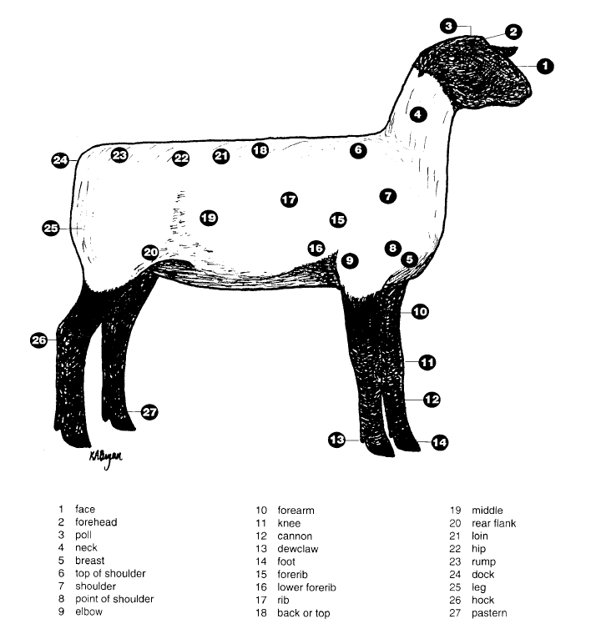

**\***Picture from: Mississippi 4-H Livestock Judging Manual

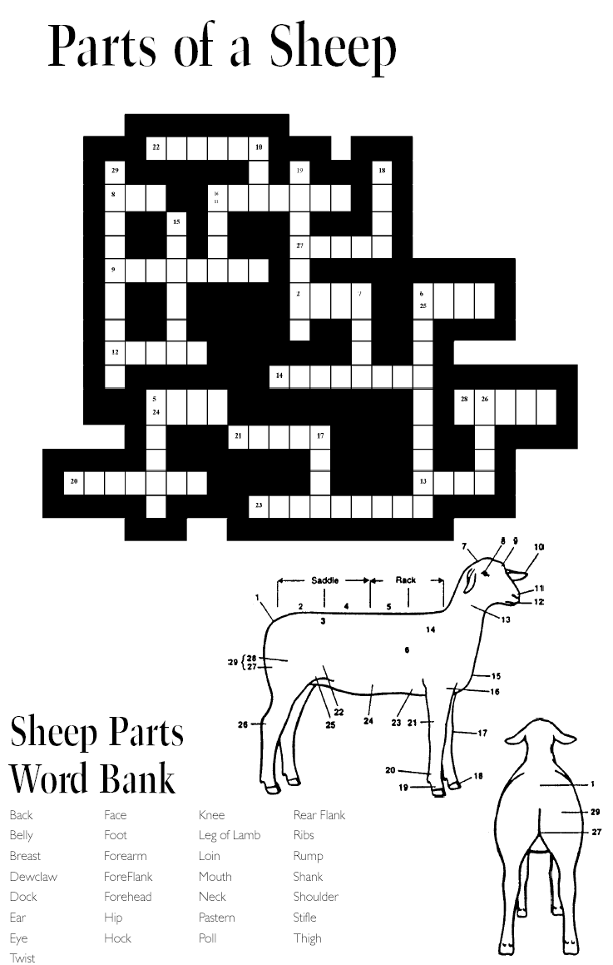

Signature: ___________________

**\*** Crossword from: Wyoming 4-H **____________________**

Safety and Handling

Sheep are very flighty animals. Unlike cattle or pigs, sheep tend to jump and run at the sign of danger. Even though sheep are smaller than cattle or pigs, they are still just as dangerous. Always follow safety procedures when you are around animals and especially when you are in an enclosed pen with them. Below are some tips and true and false questions about sheep safety and handling. Work with your mentor to fill out this page. Make sure you understand everything that is being expressed on this page and throughout the booklet.

Safety Tips

* Sheep are flock animals and tend to be uncomfortable when they are separated from the flock.
* Rams, like bulls, should not be trusted. Never turn your back on a ram while you are in a pen with them.
* Ewes, like cows, can be very protective and defensive of their young.
* Sheep have a blind spot that is directly behind them. Approaching them from behind will scare them. Announce your presence when approaching sheep by whistling or softly talking.
* Use gates to confine animals, not a group of people.

True or False

Circle T for True statements and F for False statements.

T **F** Sheep are calm animals all of the time.

T **F** It is ok to try and corner sheep with a group of people.

**T** F Sheep tend to stay together in a flock.

**T** F Ewes and Rams are the most dangerous.

Signature: ____________________

____________________

What does it take to raise sheep?

Has your mom or dad ever told you to “Eat your vegetables” or “Drink milk, it will make you big and strong”? I bet they have. Like your parents want you to be healthy and strong, so too should you want the same for your lamb. You get to play parent, in a sense for the time you have with your lamb. Just like your parents you and your mentor are responsible for feeding it, making it healthy if it is sick, bathing it, giving it shelter, etc. In this part of the booklet you will learn how to properly raise a lamb so it is in tip-top shape by the time fair comes around.

Is your lamb having a bad day or is it really sick?

One of the most important things you want for your lamb is good health. If your animal is not healthy, they could stop eating and drinking, and in turn, they will not gain weight which is what we want them to do. Below are some signs for you and your mentor to use when you observe your lamb for sickness.

Signs of a sick lamb:

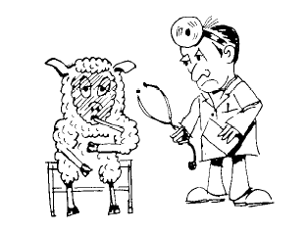

* Droopy ears
* Dull, watery eyes
* Coughing
* Not eating as much as usual
* Slow moving
* Labored breathing

(The best way to prevent your animal from being sick is to make sure you only bring in healthy animals to your farm.)

*Information and Picture from USC Davis

My Sheep Observation Log

Fill out the observation log below, include what the lamb is doing like eating, sleeping, playing, etc. For each time period observe for at least 30 minutes, so you will get to know what a lamb does all day.

|  |  |  |
| --- | --- | --- |
|  | What Sheep Did | Amount of Time |
| Morning |  |  |
| Afternoon |  |  |
| Evening |  |  |

*Chart from 4-H Skills for Life, Sheep 1

Management Tips

It is very important that you understand how to manage sheep, not only because you are working with one for the fair but you should know how sheep act and how to deal with them if you happen to be around them in the future. Below are some management tips to help increase your understanding of how sheep operate and how to deal with them.

* Minerals such as salt and Vitamins are also important in the feed diet.
* Never allow sheep to have any copper. It will cause sheep to die.
* Vaccinate against harmful diseases.
* Never make abrupt changes in the sheep feed.
* Feed lambs on a regular schedule.
* Shear lambs once after selection and before they are shown.
* Sheep should be exercised daily starting in mid June.
* Sheep should always have fresh, clean water in front of them, this helps keep the body functioning.
* Protein is a must have in the lambs diet.
* An inadequate amount of energy will reduce intake and slow growth. Make sure the lamb’s feed has carbohydrates and fats in it.

A Home is a Home of Course!!!

VS.



Home #1 Home #2

Who belongs where? This is the question that poses an interesting debate. You as a human have a certain type of place that you call home and so does an animal. So, what is the difference? Well don’t get discouraged because it will all be explained to you right now!

A home is a place where you go to get out of the weather, a place for you to sleep, a place where you spend time with your family eating meals and a place where you can relax after a long day at school. Well, after reading that description are you still a little confused about the difference between the houses? I am. Could you help me out? In the space provided below list some comparisons between the two homes to show their similarities and their differences. After you have put down some of your ideas, write a couple of sentences describing where and why an animal lives where it does.

Home #1 (EXAMPLES) Home #2 (EXAMPLES)

___4 walls and a roof______ _4 walls and a roof_______

_Bedrooms_______________ _Stalls_________________

__People live here________ __Animals live here______

________________________ _______________________

________________________ _______________________

________________________ _______________________

WHICH DID YOU CHOOSE?

Animals live in home 2 Signature: ______________________ ______________________

Sheep Feeds

Sheep could have the nickname “Lawnmower” considering that is what they love to do. The majority of sheep meals consist of grazing on pasture grasses and some weeds. Sheep will usually graze about 7 hours a day, mostly around sunrise and sunset. Grazing sheep must be careful of certain weeds which could cause sheep to become ill, they include: Common Milkweed, Jimsonweed, Lambsquarter, Pigweed and Sudangrass. If grazing land is not available sheep may be fed hay, silage, grain or a combination of those. Grain is considered to be candy for sheep and like children, sheep can, and will, get too much grain which will cause them to become sick. Persons feeding sheep must give them the proper amount so they do not become sick. Below are some pictures of common foods for sheep. Can you name what each item is?

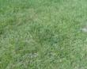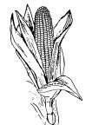

1. Grass 2. Corn

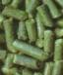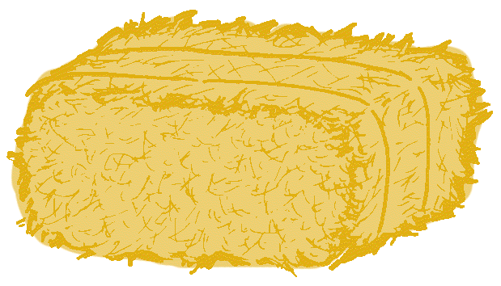

1. Pellets 4. Hay

Signature: ______________________

______________________

Fitting and Showing

Fair week is soon approaching, but before you make your way to the fair grounds there are a few things you should learn and take with you to the fair. The most important thing you should learn before you head to the fair is how to properly fit and show your lamb. You should also learn and understand what is used to properly get your lamb ready to show, including brushes, feeds, show ring attire and much more. These next couple of pages will explain all of this and more, so put your learning caps on and here we go!

Below are pictures of fitting supplies needed to properly fit a lamb for a show.

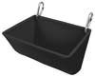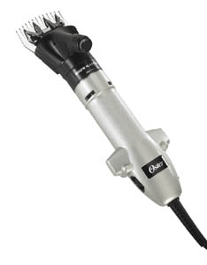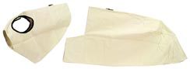

1. Clippers 2. Blanket and Hood 3. Feed Bucket

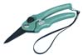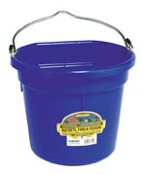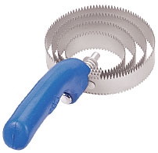

4. Water Bucket 5. Halter 6. Curry Comb 7. Hoof Trimmers

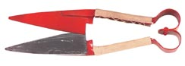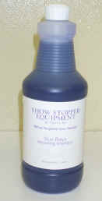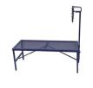

8. Hand Shears 9. Shampoo 10. Sheep Grooming Stand

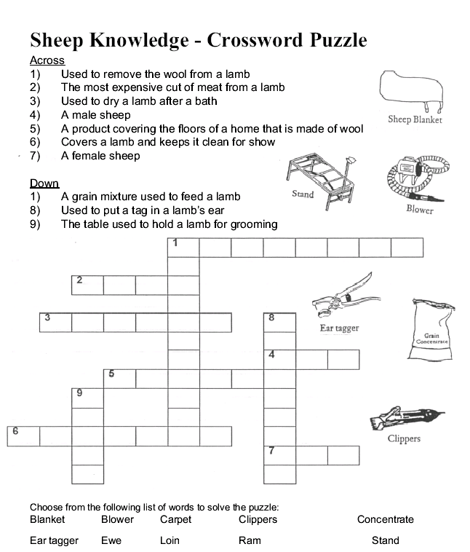

Signature: _______________________

_______________________

*Crossword from: North Carolina Extension Service

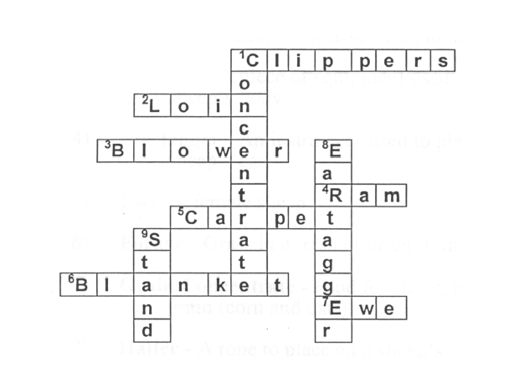

Training and Grooming

Here are some suggestions for training the lamb how to lead and set up. The lamb you are working with may already be halter broke, but in case it is not you and your mentor can work together to teach the lamb what it needs to know.

* Halter breaking is an excellent way to start calming the lamb down and getting it ready to show.
* Lambs should be caught, around the chin or in the flank area by your mentor or someone bigger than you.
* A rope halter should be put on the lamb and your mentor can hang onto it. After it is used to the halter the mentor can try to lead it with someone walking behind. Work with lambs for only short periods of time and in the coolest part of the day. After the lamb is used to leading, you can start working on setting its feet.
* If the lamb is tied up, never leave it alone.
* While your mentor is holding the lamb, position its feet properly so it can become accustomed to setting up. The lamb should be set up squarely.
* Cloverbuds will not be leading the lamb without a halter.
* YOU SHOULD REMAIN STANDING. DO NOT SQUAT OR KNEEL.
* After the lamb will stand, walk, and be set up, your next task is to teach them to brace or push, but this does not need to be done as a cloverbud.

Sheep Fitting Hints

Here are some fitting hints that your mentor can perform and you observe.

* Shear market lambs at least one month prior to show and then again one to three days before the show.
* Shear medium wool breeding ewes six to ten weeks before the show.
* For breeding sheep comb the entire fleece with a circular curry comb to break up the fleece. Then fluff the fleece with a wool card.
* On breeding sheep trim the ends until you have a smooth surface.
* Place a clean blanket on the sheep after washing and trimming to keep it clean.

Proper Fitting Techniques

* + Lambs should be washed prior to shearing.
  + Use a bath towel or blow dryer to dry the lamb.
  + Market lambs should be sheared smooth. Clippers should run parallel to the length of the body rather than vertically.
  + Wool below the knees and hocks should not be shorn.
  + Leaving the wool on the legs improves the balance and “eye appeal” of lambs.
  + After shearing cover the lamb with a lamb tube or blanket to help keep it clean.

Signature: _____________________

_____________________

Showing

A big part of exhibiting an animal is having the ability to have good showmanship. Showmanship not only involves knowing how to show an animal and present it to a judge, it also includes being courteous to your fellow showpersons, being polite and appreciative to other exhibitors, showing respect for the judge, and having knowledge about the animal. All of these put together makes an exhibitor a 1st place showmanship winner! Below is an area for you to fill out what characteristics a good and bad showperson possess.

List 5 qualities of a good showperson: (EXAMPLES)

1. __Respectful___________________________________________
2. _Courteous_____________________________________________
3. __Knowledgeable________________________________________
4. ______________________________________________________
5. _______________________________________________________

List 5 qualities of a poor showperson: (EXAMPLES)

1. __Not being polite _______________________________
2. __Disrespectful___________________________________________
3. ________________________________________________________
4. ________________________________________________________
5. _______________________________________________________

Signature: ______________________

_______________________

By-Products

Did you know that not all of a sheep will end up as meat and wool? An animal is composed similarly to you and I, we both have bones, intestines, blood, and other internal organs that are not eaten. Those other parts are good for something though, instead of throwing them in the garbage they are processed into useful items that you and I use everyday. How many things can you think of that are some sort of sheep by-product? Use the word search to find them.

|  |  |  |  |  |  |  |  |  |  |  |  |  |  |  |  |
| --- | --- | --- | --- | --- | --- | --- | --- | --- | --- | --- | --- | --- | --- | --- | --- |
| S | W | O | L | L | A | M | H | S | R | A | M | A | A | R | O |
| G | B | E | N | L | M | Q | S | A | A | L | A | L | S | R | A |
| N | A | P | I | A | N | O | K | E | Y | S | G | M | N | F | S |
| I | S | I | F | M | O | I | W | N | T | L | N | A | O | T | T |
| R | E | Z | I | L | I | T | R | E | F | E | V | L | I | R | E |
| T | B | T | L | O | O | O | T | A | L | R | E | O | T | U | A |
| S | A | C | M | P | S | Z | M | T | O | E | S | A | O | G | N |
| T | L | O | O | S | N | N | A | P | Z | L | N | S | L | O | S |
| N | L | P | Y | N | I | I | O | C | I | R | I | I | G | Y | H |
| E | S | U | S | O | S | N | I | Y | R | S | C | O | N | T | E |
| M | A | E | R | C | G | N | I | V | A | H | S | I | I | O | E |
| U | O | K | A | P | L | A | E | L | I | R | R | R | N | F | P |
| R | T | A | N | N | T | T | R | P | M | O | C | A | N | N | P |
| T | A | M | A | H | M | N | T | T | G | R | M | I | A | T | E |
| S | U | E | I | S | S | N | K | P | A | A | N | T | T | I | L |
| N | A | A | O | A | I | T | O | T | T | T | R | I | E | G | T |
| I | N | S | U | L | A | T | I | O | N | R | E | N | A | A | S |

Instrument Strings Yogurt Makeup Sheep Pelts  
Piano Keys Fertilizer Tanning Lotion  
Film Crayons Baseballs  
Marshmallows Shaving Cream Insulation  
 Signature: _________________

_________________

Glossary

Barrow- A male pig that is castrated.

Boar- An uncastrated male pig.

Bovine- An ox, cow or related animal.

Breed- A group of sheep that look alike and have the same ancestors.

Bull- A male animal that has not been castrated.

By-Product- Something made from “leftover parts” after a main product is made.

Calf- Young animal of either sex, usually less than one year old.

Castration- Removing te4sticles from male animals.

Creep feeding- Giving lambs extra feed when they are still nursing.

Cow- A female heifer that has had a calf.

Cud- Regurgitated food.

Dam- The female parent, the mother.

Docking- Removing long tails from baby lambs.

Ewe- A female sheep.

Ewe Lamb- Female sheep that is less than one year old and is usually not bred.

Feedstuff- Material used for feed.

Fleece- The wool from one sheep.

Fitting- The clipping, washing and grooming of animals for show.

Flock-= A small group of sheep.

Gilt-A young female pig that has not yet produced her first litter.

Hay- Livestock feed made from grasses that have been cut and dried so they can be stored without molding.

Heifer- The young bovine female that has not calved yet.

Herd- A group of animals particularly cattle, horses, pigs or goats.

Horned- An animal that has horns.

Lamb- A sheep under one year of age or the meat from young sheep.

Litter- The group of piglets born to a sow at one time.

Livestock- Farm animals raised for milk, meat, work and wool; includes beef and dairy cattle, swine, sheep, horses and goats; may also include poultry.

Market Weight- The weight of the animal when sold for processing.

Muzzle- The nose of a sheep.

Offspring- Animals born to a parent, or later generations of the same family.

Pastern- The region of the foot or leg between the hoof and the dewclaw.

Pasture- Grasses or legumes grown for grazing animals.

Poll- The forehead of a sheep.

Polled- An animal that naturally has no horns.

Progeny- Offspring.

Purebred- An animal descended from a line of ancestors of the same breed; may or may not be registered.

Ram- A male sheep, also known as a buck.

Registered- Purebred animals whose pedigrees are recorded in the breed registry.

Showmanship- Presenting an animal at a showing including proper fitting of the animal, showing and exhibiting appearance.

Silage- A crop that has been turned into animal food through fermentation in a silo or stored with little exposure to oxygen.

Single- One lamb born with no brothers or sisters.

Sire- The male parent; the father.

Sow- A female breeding hog that has produced one or more litters.

Steer- Male castrated when a calf.

Tagging- Practice of shearing wool from udder and dock region.

Triplets- Three lambs born to a ewe at the same time.

Twins- Two lambs born to a ewe at the same time.

Udder- The mammary glands, including the teats or nipples of farm animals.

Weaning- Removing lamb from the ewe to stop nursing.

Wether- A male sheep that has been castrated.

Yearling- An animal between one and two years of age.

Pictures

As you and your mentor begin to work together on this booklet and the lamb, take some pictures to add to your presentation. These pictures will help show what you and your mentor have been doing all these months.

What is the most important lesson learned?